# Discord Guide

## Installing Discord

Link to the official discord site: [https://www.discordapp.com/](http://discordapp.com/)

Press the Download button.

NOTE: Do not open Discord from your browser. **It does not have screenshare**

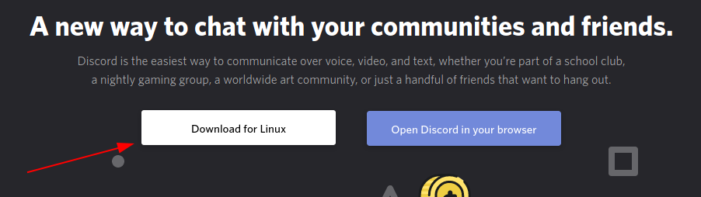

**NOTE**: Discord is cross-platform: there is a Windows and Mac version and the button will download the version suitable for your OS.

This should be the first thing you see when you open Discord:

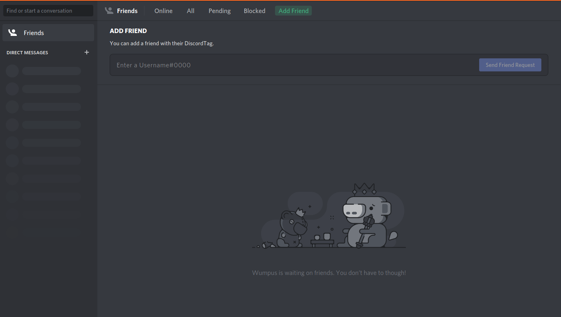

## Getting Connected with SoftUni's Discord Account

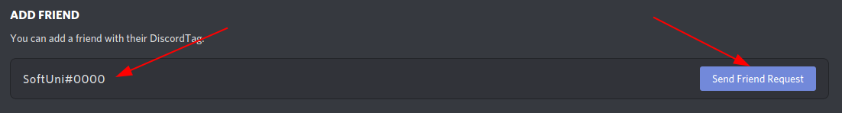Once SoftUni accepts the request, send a private message with this information:

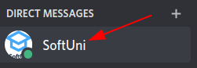

Username – Project Name – Github link



## Calling and sharing screen

Press this button to start a conversation with someone:



And this button enables screen sharing to the person you are talking to. It is recommended to share the Entire Screen instead of a specific application window.

